Janeka Martin
QKN2 — QKN1 Task 2: Coding
Analytics Programming — D598

Scenario

You have been hired by a small investment company that manages an equity fund comprised of 150 U.S. companies across multiple industries. The fund managers are looking to rebalance the fund’s holdings and would like you to provide an analysis of the companies’ performance based on data from the most recent quarter. The data can be found in the supporting documents section as “D598 Data Set”.
To aid in your analysis you must write programs in Python or R to perform the following tasks:
• Import the data file into a data frame.
• Identify any duplicate rows in the data set.
• Group all IDs by state, then run descriptive statistics (mean, median, min, & max) for all numeric variables by state and store this result as a new data frame. (Code should be modified from “D598 Task 2 Original Code” in the supporting documents section)
• Filter the data frame to identify all businesses with debt-to-equity ratios that are negative.
• Create a new data frame that provides the debt-to-income ratio for every business in the data set. Debt-to-income ratio is defined as long-term debt divided by revenue.
• Concatenate the debt-to-income ratio data frame you created with the original data frame.

In this task you will create a report for your stakeholders by doing the following:

- Explain how the code works for the program you submitted in Task 2.

- Import Libraries:

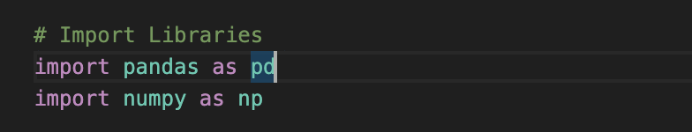

To successfully create a program for data analysis in Python, the typical first steps are to install the necessary libraries. The Pandas and NumPy libraries enable the program to store data in working memory, organize it into a tabular format, manipulate data, and perform calculations efficiently (Western Governors University, 2020). According to Vanderplas (2016), pandas objects can be thought of as enhancements that allow rows and columns to be identified with labels. Additionally, NumPy is fundamental to the process of data science and is essential for efficient storage and manipulation of numerical arrays (Vanderplas, 2016).

- Load the Excel File:

After importing the libraries, the next step is to load the Excel data file into the program using the pandas function read_excel(). This function is used to read the “D598 Data Set.xlsx” file and store it in a data frame named df, making the data accessible for cleaning, analysis, and visualization.

- Checking for Duplicates:

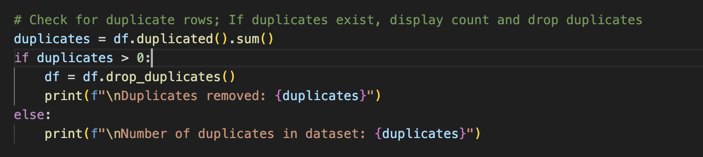

Once the data is loaded into a data frame, the program performs data-cleaning steps to ensure accuracy before analysis begins. The pandas library provides the duplicated() and drop_duplicates() functions to detect and remove duplicate rows within the dataset (Western Governors University, 2020).

The program identifies and counts any duplicate rows using df.duplicated().sum and removes them using df.drop_duplicates(). If duplicates are found, the program prints the number of removed duplicates; if not, it displays the total number of duplicates found. This process ensures that unique and reliable records remain in the dataset.

- Grouping by State and Calculating Descriptive Statistics:

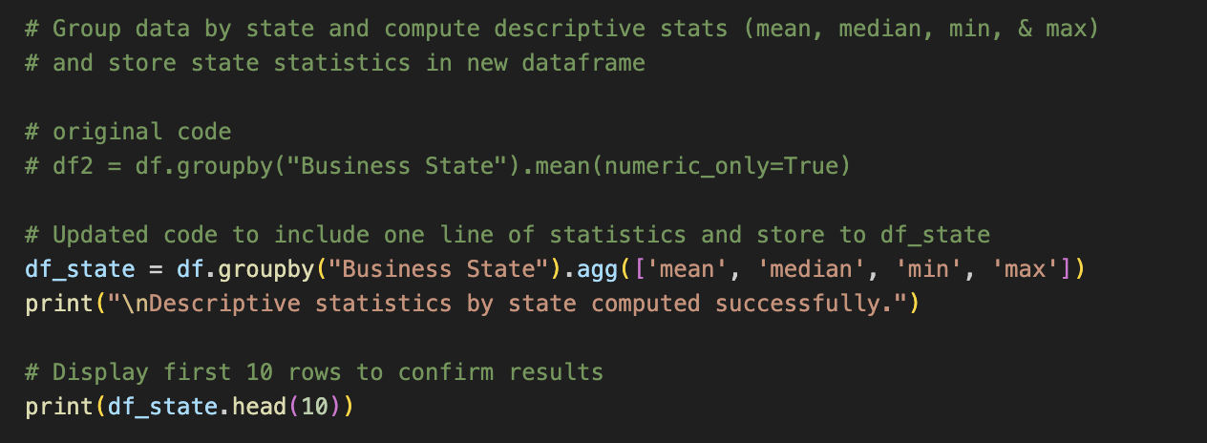

According to Vanderplas (2016), a fundamental component of many data analysis tasks is efficient summarization, which involves computing aggregations such as the mean, median, minimum, and maximum to understand patterns in large datasets.

To group all business IDs by state, the program uses df.groupby() combined with. agg() to calculate these descriptive statistics for all numeric values. The results are saved to a new data frame named df_state, which summarizes company performance metrics by state for easier comparison and insight generation.

- Filtering Negative Debt-to-Equity Ratios:

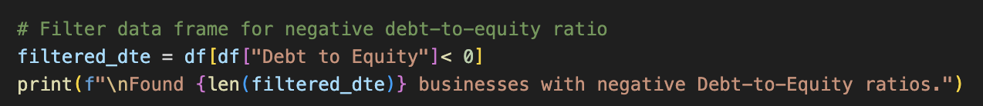

As part of the data analysis, the program filters the dataset to identify all businesses with debt-to-equity ratios. This is accomplished by filtering on the “Debt to Equity” column for any businesses with a ratio of less than zero. The results were then saved to a new data frame named filtered_dte. The len() function is then used to display the number of businesses that fall into this category. These steps help stakeholders interested in identifying businesses with financial liabilities in the data.

- Calculating the Debt-to-Income Ratio:

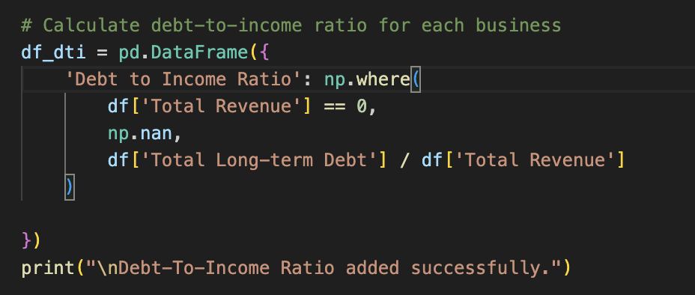

Next, the program calculates the debt-to-income (DTI) ratio for each business. A new data frame, df_dti, is created using NumPy’s np.where() function. These steps include a critical logical condition to handle division by zero:
- If Total Revenue = 0, the DTI ratio is recorded as Nan (Not a Number) to avoid a mathematical error.
- If Total Revenue is greater than 0, the DTI ratio is calculated as Total Long-term Debt divided by Total Revenue.

- Concatenating Data Frames:

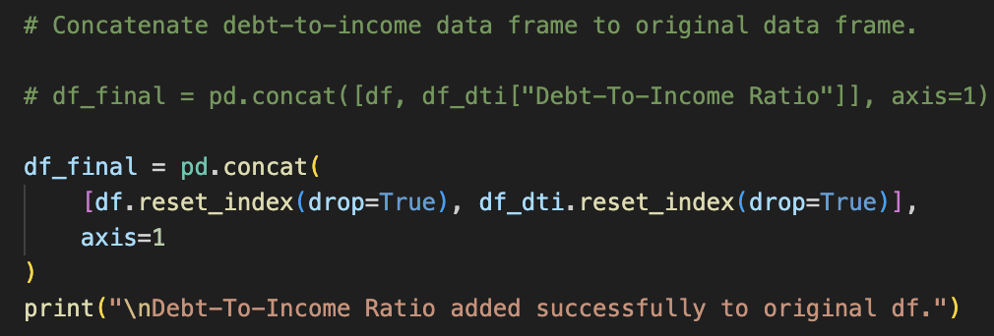

Finally, the program concatenates the new df_final data frame with the original dataset using the pd.concat() function. The result stores the combined business information with the new Debt-to-Income ratio column. The completed final_df provides a comprehensive dataset, ready for further analysis or visualization.
Conclusion:
In summary, this Python program automates essential parts of the data analysis process, including data cleaning, summarization, and calculation of key metrics for the 150 companies in the equity fund. It ensures accuracy by handling missing and duplicate data, introduces key financial ratios for insight, and produces a structured and ready-to-use final dataset for informed decision-making.
- Provide 4 customized data visualizations.

- The below chart plots Top 5 states that earn the most revenue.

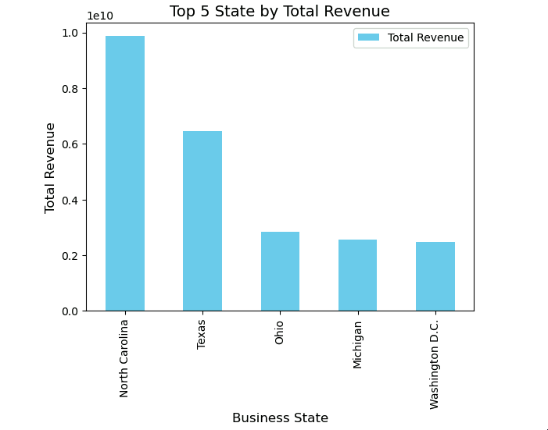
- The below chart plots Top 5 states that earn the most revenue and compares the highest debt

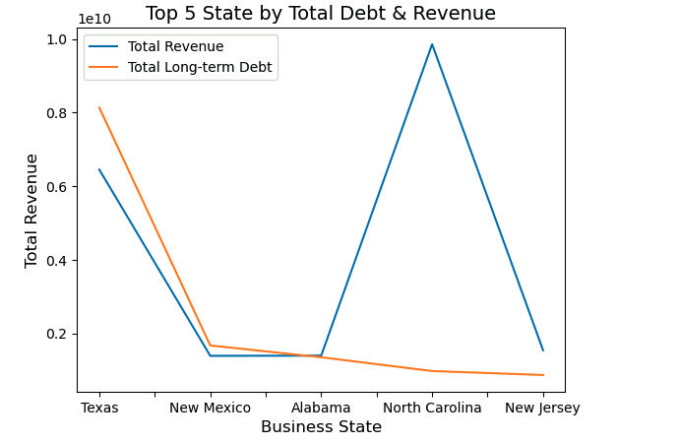

- The below chart plots Top 5 Businesses by Debt to Income

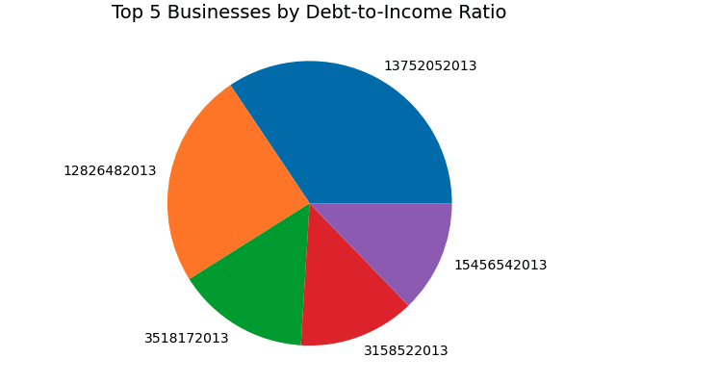
- The below chart plots Top 5 Businesses Debt to Equity

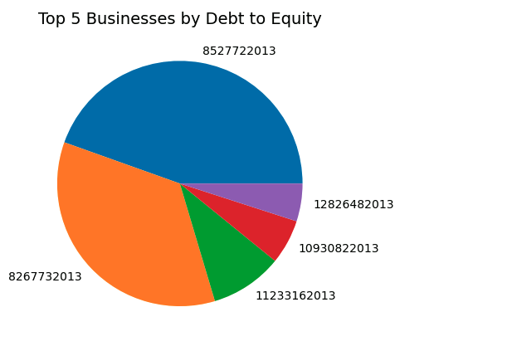

- Explain how customized visualizations in part B were created.

The custom visualizations were created using Python’s Matplotlib and pandas libraries to analyze findings within the dataset. (The Python Graph Gallery, n.d.; LinkedIn Learning 2020a, 2020b)

- This visualization provides insights into states generating the highest revenue by grouping the data frame by Business State and calculating the sum of the Total Revenue. The bar chart was created using the df.plot() method with the kind="bar" argument, and customized with a color scheme (color="skyblue"). A title was added to the chart, along with x and y labels.

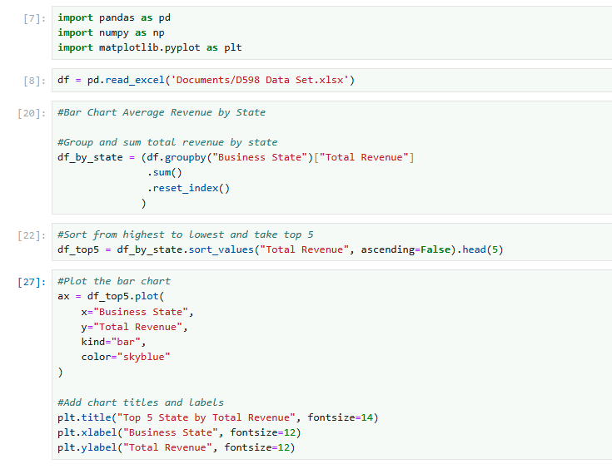


- The line chart utilizes the plt.plot() function from Matplotlib to display and compare potential trends in debt values and revenue across the top states. This visualization groups the data frame by Business State and calculates the sum of both Total Revenue and Total Long-term Debt. Customizations included adding a title to the chart, along with x and y labels.

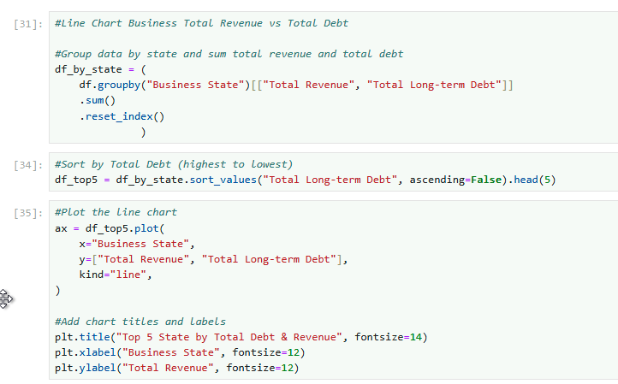
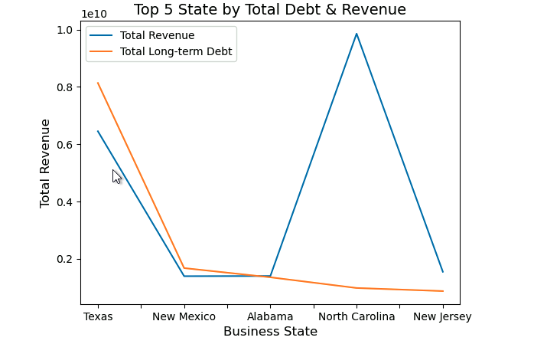

- The pie chart was created to highlight the Top 5 Businesses with the highest debt-to-income ratios. The plt.pie() function was used to label each slice of the pie chart with its Business ID. Lastly, a title was added to the chart. This visualization provides insight into how each business’s debt-to-income ratio contributes to the total among top performers.
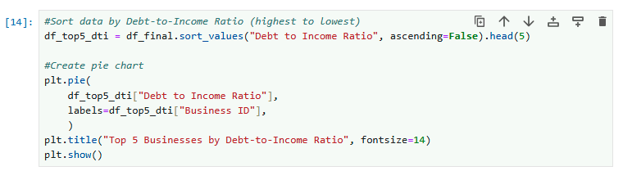

- The pie chart was created to highlight the Top 5 Businesses with the highest debt-to-equity ratios. The plt.pie() function was used to label each slice of the pie chart with its Business ID. Lastly, a title was added to the chart. This visualization offers insight into the extent to which top businesses use debt to finance their assets.
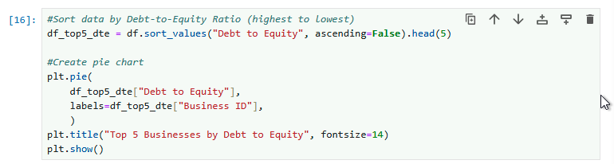


D. Acknowledge sources, using in-text citations and references, for content that is quoted, paraphrased, or summarized.

Vanderplas, J.T. (2016.) Python data sciencehandbook : essential tools for working with data.
Beijing Etc.: O’reilly, COP

Western Governors University (2020). Lesson 1.2: Data Cleaning (Duplicates, Missing Data, Outliers, etc.)

The Python Graph Gallery. (n.d.). Mathplotlib charts documentation and examples. https://python-graph-gallery.com/matplotlib/

LinkedIn Learning. (2020a). Python for data science essential training part 1: Creating standard data graphics. https://www.linkedin.com/learning/python-for-data-science-essential-training-part-1/creating-standard-data-graphics?resume=false&u=2045532

LinkedIn Learning. (2020b). Data visualization with Matplotlib and Seaborn: Plotting methods. https://www.linkedin.com/learning/data-visualization-with-matplotlib-and-seaborn/plotting-methods?resume=false&u=2045532

